A BLUEPRINT FOR

OUR RECOVERY

A MESSAGE FROM TODD

SAN DIEGANS —

We have experienced cataclysmic change since the COVID-19 pandemic struck in March. A deadly foe has quickly taught us the fragility of every social structure on which we rely. We can say without any doubt that every single San Diegan has been impacted by this pandemic. COVID-19 has taken hundreds of lives in San Diego, sickened thousands, and brought our economy to its knees.

When California first went into shutdown and we were all locked away at home, I spent my days calling healthcare providers, business owners, government officials, and nonprofit leaders, trying to understand the impacts and find ways to help. Some businesses, both big and small, operated on such a thin margin that they were gone in a week. Thousands of workers, some who hadn’t missed a day of work in their lives, found themselves nearly instantly unemployed. Nonprofits saw revenues plummet as struggling San Diegans couldn’t give at pre-pandemic levels.

It quickly became apparent that we have a new dividing line in our economy, between those whose jobs allow them to work at home, and those who cannot. It is also clear that people of color are paying a higher price for COVID-19, both in terms of their health and their economic well-being.

Our challenges in responding to the pandemic are undoubtedly great. But respond we must, with everything we can muster. This is no time for partisanship or politics. Although we can’t stand shoulder-to-shoulder, we can come together.

Back to Work SD is a tremendous effort by people who know San Diego best. Leaders in their professions and their communities came together and developed this inspired, thoughtful set of recommendations for how we can recover from COVID-19 as safely and quickly as possible. These guidelines were created with the unified belief that we are all inter-connected as individuals, businesses, and the many other organizations that are central to San Diego’s well- being. It is only in working together that we can put the impacts of this pandemic behind us.

A MESSAGE FROM TODD CONTINUED

I owe everyone who participated in this process a tremendous debt of gratitude. Every member of the Back to Work SD team has truly invested in the recovery of our city. I would especially like to thank co-chairs Congressman Scott Peters and Paola Avila, Vice President for International Business Affairs at the San Diego Chamber of Commerce. Their leadership helped propel this effort forward. Additionally, we thank Sarah Moga Alemany. Sarah generously volunteered her time and talent to turn the group’s recommendations into this document.

San Diego’s response to the tragedy of COVID-19 will become a part of our history. It is a time for bold, inspired leadership. San Diego has seen financial crisis before, and I was proud to serve as Interim Mayor during that time and get our city back on track. Now more than ever, we need steady leadership and vision to bring the city together and protect people’s health, strengthen our economy, and make sure people can make ends meet during the COVID-19 pandemic and beyond. We know San Diego is up for the challenge, and I look forward to leading our city through our recovery.

Todd Gloria

#Forallofus

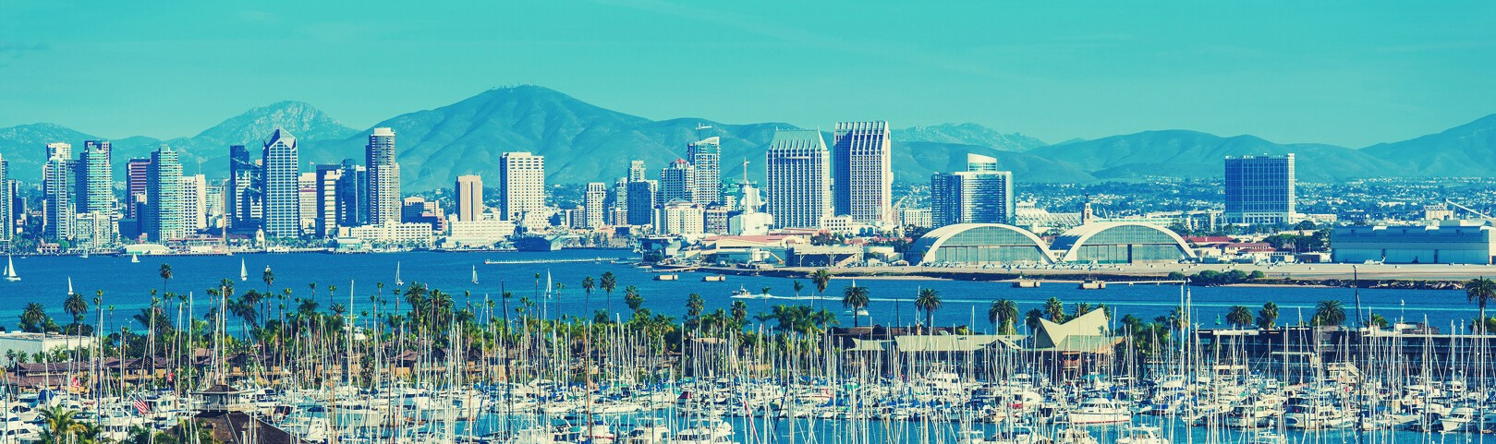

A LETTER FROM THE CO-CHAIRS

San Diego is well known as a beautiful city, and it certainly is. But we know it is also a smart and creative city, and it has a culture that looks forward, welcoming and not fearing tomorrow, seeing opportunity ahead. That culture has been built by a unique level of communication and collaboration among our citizens.

The following document is the product of tremendous collaboration among a broad cross section of our city that share a common objective: helping our next Mayor, Todd Gloria lead San Diego toward a stronger tomorrow.

Without a doubt, the pandemic has thrown us off our game. Now is a time of great uncertainty, a convergence of economic pressure and isolation due to the pandemic, and anger and sadness stemming from years of social and economic injustices. Systemic health and social inequities have put many people from racial and ethnic minority groups at greater risk both economically and health
wise. The pandemic has in fact affected everyone in different ways and we know things will be different for a while, but what’s next? What will the future city look like for us and our children? What have we learned from this experience that we can keep, and what do we realize we must reclaim?

These are not ordinary questions for a mayor, and there is not a lot of academic literature talking about the final solutions. Todd tasked us with drafting recommendations that would help him
develop a comprehensive plan for San Diego’s recovery and resiliency. Over the past few months, we met by video conference calls, exchanged ideas, gathered yet more data and held hearty discussions analyzing draft solutions. We asked each member of the task force to reach out to their networks
and communities to further assess needs and gather input. In business this is called the Voice of the Customer, VOC, but we’re coining VOC to be the Voice of the Community. The result is a set of effective guidelines and actionable items warranted in challenging times such as these.

This document is not only a roadmap to get San Diego back to work, it is a bold plan to reimagine San

A LETTER FROM THE CO-CHAIRS

CONTINUED

Diego – the way we live, the way we govern, the way we do business, with more equitable and inclusive policies. Its successful implementation depends on everyone working together, but San Diegans are known for our collaborative spirit, so we got this! With Todd at the helm, working for every San Diegan, we are not only optimistic about our city’s future, we are convinced we will come out stronger.

- Congressman Scott Peters, U.S. House of Representatives, 52nd District
- Paola Avila, VP for International Business Affairs, San Diego Regional Chamber of Commerce

BACK TO WORK SD TASK FORCE

MEMBERS

U.S. Congressman Scott Peters (CA-
52)
California State Treasurer Fiona Ma San Diego County Supervisor Nathan Fletcher
San Diego Unified School Board
Member Richard Barrera
Dr. Cheryl Anderson, Professor and Interim Chair of the Department of Family Medicine and Public Health, UC San Diego School of Medicine
Jason Anderson, Renewable energy/clean technology advocate Paola Avila, VP for International Business Affairs, San Diego Regional Chamber of Commerce
Dr. Tahir Bhatti, Wellness Physician, UC San Diego Health
Phil Blair, Executive Officer,
Manpower HR Staffing
Betsy Brennan, President and CEO, Downtown San Diego Partnership Mark Cafferty, President &CEO, San
Diego Regional Economic Development
Corporation
Bill Fulton, Urban Planner
Dr. Alan Gin, Economist, University of
San Diego
Jay Goldstone, former COO, City of San
Diego
Dr. Kyra Greene, Executive Director, Center on Policy Initiatives
Mikey Knab, Restauranteur
Keith Maddox, Executive Secretary Treasurer, San Diego & Imperial Counties Labor Council
Ari Matusiak, Former White House Director of Private Sector Engagement (2011-2014)

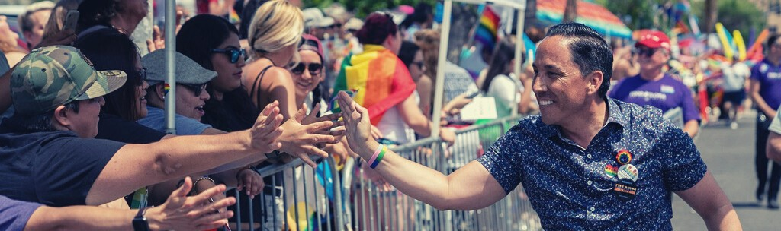

#Forallofus

BACK TO WORK SD: TASKFORCE

CONTINUED

Namara Mercer, Executive Director, San Diego Lodging Association
Dr. Fadi Nicolas, Chief Medical Officer, Sharp Behavioral Health Services Jason Paguio, President/CEO, Asian Business Association San Diego Maya Rosas, Director of Policy, Circulate San Diego
Dr. Dara Schwartz, Lead Psychologist, Sharp Mesa Vista Hospital
Admiral Dixon Smith (ret), EVP, R.E. Staite Engineering, Inc.
Jason M-B Wells, San Ysidro Chamber of Commerce
Angie and Jon Weber, Cowboy Star/California Restaurant Association

CONTRIBUTORS

Marshall Anderson, VP, Government Relations, Downtown San Diego Partnership
Courtney Baltiyskyy, MPA, Early Care and Education Nonprofit Leader
Kim McDougal, Early Care and
Education Nonprofit Leader

Craig Milgrim, M.S. Trustee, San Diego
Community College
Carolyn Perkins, Board Liaison, Downtown San Diego Partnership

JUMP-STARTING

OUR RECOVERY

San Diego’s recovery requires a deep investment in what makes San Diego a great city -- the people who live here. We must make intelligent investments in schools, childcare, housing and homelessness, infrastructure, and small businesses. As Mayor, I will boldly pursue a recovery that strengthens San Diego’s economy and recognizes the value of all members of our community.

#Forallofus

Back to Work SD: A Blueprint for our Recov ry | Todd Gloria for Mayor 07

JUMP-STARTING OUR RECOVERY

In making decisions about reopening our local economy, we must first recognize that there can be no recovery without first addressing the needs of children and families. All other efforts to reopen our economy depend first on a safe, timely, and equitable return to school and childcare provision.
SUPPORT YOUTH AND FAMILIES

Childcare ensures that parents can continue to work, seek employment, or further their own education. Funding access to quality, affordable childcare is key to breaking cycles of poverty for vulnerable families. Childcare is also critical for the well-being of the next generation of San Diegans. This is when brain architecture is developed. Children who receive quality childhood education are healthier, stay in school longer, and earn more in their future careers.

Schools and childcare providers have been hard hit by the pandemic. More than 600 childcare centers in San Diego County closed temporarily during the early days of the pandemic. A study from UC Berkeley found that in Southern California, 62% of childcare programs experienced a loss of income due to low attendance or families not paying the fees, and 81% made staffing changes including laying off employees or cutting benefits. The locally funded emergency child care voucher program provided through the San Diego COVID-19 Children’s Fund has received more than 2,300 applications .

Key Strategies to Support Schools and Childcare Providers:

1. Prioritize safe reopening of schools and childcare before opening other sectors.
2. Ensure that city parks, libraries, and other facilities are accessible to students.
3. Scale up funding to keep childcare providers in business.
4. Subsidize childcare for essential workers, others impacted by COVID-19.
5. Coordinate childcare and school support programs through Pandemic Childcare and Education
Resilience program.
6. Reduce childcare training and certification costs through partnerships with community college programs.
7. Simplify and consolidate childcare resource information and provider navigation.
8. Accelerate efforts to provide high-speed internet access for all pre-K through high school students and their families.

9. Provide safe and affordable transportation options for all San Diego students.
10. Strengthen partnerships with organizations providing special support to homeless youth and families.
11. Explore options to lease excess land for childcare serving military families.

PARTNERING WITH SCHOOLS AND CHILDCARE PROVIDERS

No matter the quality of any online learning program, the vast majority of students suffer significant
learning loss as well as social and emotional trauma from not being able to attend school physically. Nothing is more important in terms of racial, social, and economic justice in the City of San Diego than getting students back in school. Although our school districts operate separately from the City, transportation and access to the necessary resources for educational success absolutely falls under the City’s purview. My administration will continue to prioritize multi-agency efforts for student success -- like Safe Routes to School, Youth Opportunity Bus Passes, safe access to libraries and community centers, and ensuring that all San Diegans have reliable, affordable access to the internet and personal computing. The City can take immediate steps to give schools more options for in-person education through the safe use of municipal parks and other spaces for outdoor learning. We must also make sure that libraries and other community facilities are accessible to students through a priority or reservation-based system.

We will help childcare providers secure financial assistance such as small business loans and grants, similar to those being provided by the San Diego COVID-19 Children’s Fund. This financial support must be scaled up with any future pandemic response funds to prevent the permanent loss of childcare provision. We will develop a program to coordinate the City’s work with other agencies to support childcare providers and schools. We’ll work in conjunction with the County of San Diego and the private sector to identify how we can best support childcare providers in San Diego and expand access to affordable childcare for working families.

The ability to find and pay for childcare will continue to impact parents’ ability to go back to work. We will coordinate with YMCA Childcare Resource Service to support San Diegans with childcare navigation and access to available childcare subsidies and partner with the Community Information Exchange (2-1-1 San Diego) to provide information about the resources that exist for children, youth, and their families. Funding should also continue to support childcare costs for the children of essential workers and others impacted by COVID-19. To make childcare more accessible, we willl work with the community college system to expand training and reduce certification costs for childcare professionals. In addition to allowing more San Diegans to work in a growing and durable industry, more childcare providers also translates into more affordable choices for working families -- during the COVID-19 crisis and long after.

ASSISTANCE FOR SAN DIEGO’S MOST VULNERABLE FAMILIES

To bridge the digital divide, San Diego will partner with districts like San Diego Unified School District
(SDUSD) and private sector partners to establish high-speed internet access for all pre-kindergarten
through high school students and their families. Access to schools and childcare also requires that students have safe and reliable transportation. With so many working families struggling to make ends meet, we will pursue a partnership between the City, the Metropolitan Transit System (MTS) and SDUSD to provide free public transit for all K-14 students, as schools resume in-person instruction. Promoting the use of public transit through a Youth Opportunity Pass system will help alleviate the issue of social distancing on school buses, will give students freedom of movement, and will be an investment in building a base of lifelong transit riders.

SUPPORTING MILITARY FAMILIES

The shortage of childcare facilities is a critical issue impacting every sector, including the many sailors, servicemembers, and their families who call San Diego home. To address the unmet need, local bases are partnering with multiple cities to provide new childcare services. We will work with Navy Region Southwest to explore leasing excess city facilities for childcare services. This could include military children-only or co-military/civilian childcare facilities helping to alleviate not only active duty military childcare shortfalls, but also the broader community. San Diego should leverage its strong network of
nonprofits to ensure that military families are aware of the resources available to them. In order to address the unique challenges facing military families, San Diego must coordinate with Navy Region Southwest’s Fleet and Family Support Center, Marine Corps Installations West Marine & Family Programs, and Coast Guard Sector San Diego Family Services to make sure we’re doing our part to support San Diego’s military community.

JUMP-STARTING OUR RECOVERY

PROTECT AND HOUSE OUR HOMELESS

NEIGHBORS

Ending homelessness is a moral imperative and will be a top civic priority. Our homeless residents, many of whom are elderly or suffering from existing health conditions, are also among the most vulnerable to the virus. The latest estimates suggest about 5,000 San Diegans have no permanent home to safely shelter in place. The City, County and local nonprofits have come together to shelter and provide services for San Diego’s homeless population during the COVID-19 crisis. The “Shelter to Home” program temporarily housing homeless people in the Convention Center has been a success. Let’s continue that progress. With leadership from the City and strong regional coordination, public agencies and service providers will keep San Diegans experiencing homelessness safe, offering services under one roof, and transition as many as possible into permanent housing.

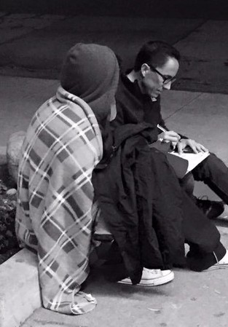Key Strategies to Protect and House our Homeless Residents:

1. Directly transition as many clients as possible from the Convention
Center to permanent supportive housing.
2. Coordinate existing funding programs to maximize efficacy.
3. Advocate for the passage and responsible implementation of
Measure A.
4. Lobby county, state, and federal agencies for additional funding to provide Permanent Supportive Housing.
5. Establish flexible rapid rehousing funds to prevent homelessness among at-risk populations.
6. Ramp up training programs for supportive service professions.
7. Work with the County to direct Mental Health Services Act funding to services for the homeless or formerly homeless.

TRANSITION FROM TEMPORARY SHELTERS TO PERMANENT

SUPPORTIVE HOUSING

Shelter to Home has temporarily housed more than
1,300 clients, regularly testing both staff and clients for COVID-19, and successfully preventing outbreaks from occurring. By early September, 525 clients had received housing and even more had been connected to resources based on their needs. In addition, San Diego received a $27.7 million grant to purchase a hotel,
which will provide an additional 340 homes for people experiencing homelessness. When Shelter to Home ends by the end of 2020, remaining clients will move to one of several temporary shelter tents or to Golden Hall.

Funding for the Convention Center should be extended until the end of the year to ensure that individuals can move directly from the Convention Center to a newly purchased hotel room, instead of shuffling through temporary shelters. Service providers have undertaken a tremendous effort to coordinate between agencies, and it’s imperative that no one is pushed out into the streets or lost in the shuffle from shelter to shelter before the new hotels are available as housing.

The $27.7 million grant from Project Homekey to help purchase hotel rooms is an important step towards providing housing. However, we must push for more funds from the State and the County to buy more hotels and house all San Diegans experiencing chronic homelessness. Passing Measure A in November will provide funding to create affordable homes for veterans, families, and people experiencing homelessness -
- changing their lives forever.

Beyond addressing the immediate needs resulting from the pandemic and the “Shelter to Home” program, San Diego must augment current funding to end chronic homelessness. Ultimately, we should apply lessons from the Shelter to Home program to future coordination efforts, even if service providers and local agencies are no longer all under one roof.

Federally, San Diego must lobby to increase available housing vouchers. At present we are simply repurposing vouchers previously used for other affordable housing to provide Permanent Supportive Housing. Supportive housing projects require many layers of funding, but funding sources are not well- coordinated. This leads to inefficiencies, expenses, and delays. In addition to increasing the funding available through Measure A, the Housing Commission can lead on maximizing limited resources available to San Diego in order to leverage state and federal funds for more homes. We also need to increase our capacity to provide supportive services. Even if a placement in a Permanent Supportive Housing project is available, local service providers are stretched thin.

We can partner with state agencies, universities, and community colleges to ramp up training for supportive service providers and other roles in affordable housing construction. These training programs should focus on the experiences of formerly homeless people and even provide priority placement for those who have experienced homeless to become incredible social workers, counselors, and more.

RAPID REHOUSING

Now, more than ever, the City should make investments in solutions like rapid-rehousing for those who need relatively modest assistance to avoid homelessness and get back on their feet. Smart prevention and diversion solutions like this can be far less expensive than allowing San Diegans to experience long- term homeless. San Diego should follow growing evidence of the efficacy of the rapid rehousing approach. A rapid rehousing program should begin by focusing on the populations most vulnerable to COVID-19 -- families with children, seniors, and those with disabilities or serious health conditions.

PUTTING MENTAL HEALTH FUNDS TO WORK

Some of our most visible homeless residents also suffer from mental health or substance use issues. Homeless or not, San Diegans suffering from mental and behavioral health issues deserve better than the sparse and fragmented services our region currently has to offer. The COVID-19 pandemic is likely to exacerbate the existing mental health crisis. We must address the mental health crisis head-on and implement real solutions for those who cannot care for themselves. There are no quick fixes for behavioral health conditions like substance abuse but there is funding available to address them. Counties across California are sitting on billions in unspent Mental Health Services Act (MHSA) funding. The County of San Diego has tens of millions in available dollars at a time when 43% of our homeless
neighbors are challenged with mental health issues. As Mayor, I will work with county officials to pair
MHSA funding for mental health services with city housing investments.

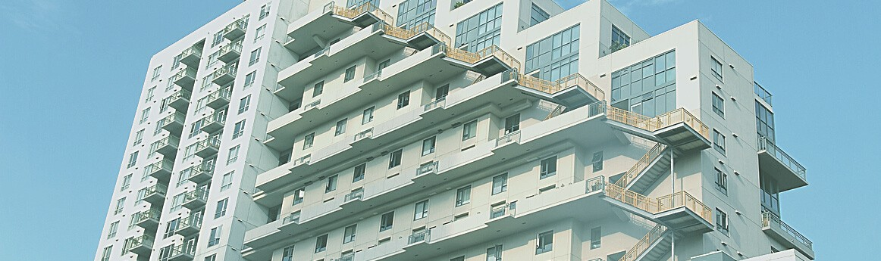

JUMP-STARTING OUR RECOVERY

PROTECT STRUGGLING RENTERS AND

OWNERS

The best strategy to ending chronic homelesssness is to prevent people from losing their homes in the first place. In the midst of a dangerous public health crisis, keeping people safely housed must be a top priority. Thousands of San Diego renters are unable to pay rent and are at risk of eviction, homeowners are falling behind on mortgage payments, and mom and pop landlords are seeing the income they depend on dry up. In this environment, the City must direct more pandemic response funding to this issue and continue lobbying for additional state and federal housing assistance.

Key Strategies to Protect Struggling Renters and Owners:

1. Extend eviction protections until largescale financial relief is available.
2. Coordinate outreach to homeowners and renters on latest protections and local legal support resources.
3. Add funding to rental assistance programs and advocate for additional state and federal aid.

IMMEDIATE ACTION TO PREVENT EVICTIONS

More than 40 percent of California households are currently unable to make full rent payments. Decisive action is needed to prevent a major eviction crisis. The state’s eviction moratorium currently requires tenants to pay at least 25 percent of their rent due beginning in September to prevent their potential eviction, which would be allowed beginning in February. San Diego’s local eviction moratorium expires at the end of September, meaning that unless it is extended, tenants could face eviction in February if they do not meet the minimum requirements as prescribed by the state. San Diego can and should go above and beyond the state’s moratorium to provide protection for families experiencing an undue financial hardship resulting from the pandemic so that a new wave of homelessness does not land on San Diego’s streets over the next few months.

ONGOING SUPPORT FOR RENTERS AND SMALL

LANDLORDS

Renters who have been laid off or who are taking care of family members need time to find new jobs and find a way to pay back rent. This cannot be done in just a few months. Beyond just extending the eviction moratorium, we must find a way to provide financial relief to tenants and landlords to provide a realistic chance of paying past due rent.

In the last budget cycle, San Diego approved a COVID-19 Emergency Rental Assistance Program, which provided $4,000 in one-time assistance to renters in need. Unfortunately, the program only had enough funding to support 3,500 families. Together with the County and philanthropic organizations, San Diego must prioritize providing rental relief for people experiencing financial hardships to prevent families
from being forced onto the streets. This is a solution that benefits both renters and landlords and the scale of the current crisis demands that far more than $15 million be allocated for rental assistance. Additional state or federal funds should be directed to this area. The City should also dedicate more resources for outreach and tenant legal support.

San Diego must also prioritize outreach to landlords who are at risk of not being able to afford mortgage payments or deal with maintenance and repair issues due to lack of rent. The City should consider targeted rental relief to help “mom and pop” landlords with access to fewer resources, and/or target smaller unit properties where there is a higher propensity of lower income families.

JUMP-STARTING OUR RECOVERY

INCREASE AFFORDABLE HOUSING IN

OUR NEIGHBORHOODS

The housing affordability crisis is a primary driver of San Diego’s homelessness and poverty and a major impediment to San Diego’s economic success. To

protect our diverse local economy, and to provide opportunities for our children and grandchildren to live in San Diego, we must increase the supply of housing. San Diego will not be a functioning city if only the very wealthy can afford to live here. In order for working and middle class San Diegans to feel that they have a future in this city and an ability to build wealth, they have to be able to climb the rungs of the housing ladder. Currently, 50 percent of San Diegans can’t find market-rate rentals they can afford.
50% of San Diegans

can't find market- rate rentals they can afford.

- SAN DIEGO HOUSING COMMISSION

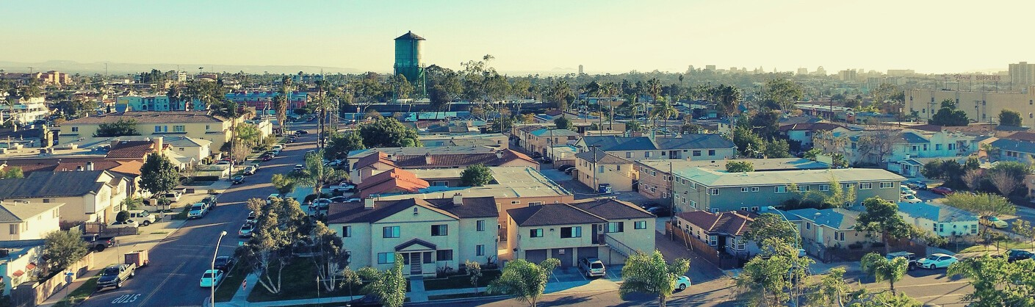

Key Strategies to Increase Affordable Housing:

1. Conduct a thorough assessment of City real estate assets for housing opportunities.
2. Bring in more state and federal funding to ensure San Diego receives its fair share.
3. Develop new policies to conserve Single Room Occupancy buildings.
4. Regulate short-term vacation rentals and tax vacant homes to maximize local access to existing housing stock.
5. Accelerate updates to outdated community plans.
6. Implement new policies to incentivize the production of more naturally affordable homes.
7. Establish a middle-income housing trust fund.
8. Create a Civic Land Trust to utilize City real estate for affordable and supportive housing.

LEVERAGING AND PRESERVING EXISTING RESOURCES

As a city with a large portfolio of real estate assets, we must focus on aligning how we use our assets with our priorities. That means using the City’s properties to increase our supply of affordable housing for San Diegans. A comprehensive assessment of available real estate assets is needed to identify properties well-suited for various types of subsidized housing and permanent supportive housing projects in every area of the City.

It’s time for San Diego to receive its fair share of the multi-million dollar Affordable Housing Sustainable Communities grants to fund affordable housing and transportation improvements. San Diego as a region has performed poorly in proportion to its share of the state's population, and we've missed out on tens of millions of dollars that would have built much-needed deed- restricted affordable homes and transportation improvements. The City can lead by convening project partners, providing technical and grant writing support, and pledging matching funds when necessary.

San Diego must take every step possible to protect existing deed-restricted or naturally affordable housing. A new strategy is necessary to safeguard dwindling single room occupancy (SRO) buildings that provide a lifeline for those that can’t find traditional housing. Regulating short-term vacation rentals and new policies to disincentivize absentee ownership -- such as a vacancy tax -- will help to preserve limited housing stock for San Diegans struggling to find affordable homes to rent or purchase.

LAND USE PLANNING AND REGULATION

An important piece of the housing solution is San Diego’s zoning and land use policies, which dictate what can be built and where. The City should continue to update out-of-date community plans to better reflect the needs of San Diego communities today, support the city’s Climate Action Plan, and contribute to the success of small businesses. Many Community Plans are over
30 years old, especially in historically underserved communities such as City Heights.

Updating Community Plans is an equity issue, because they not only dictate the types of development that are allowed, but they also update fees that are leveraged to build community assets such as parks and roadway improvements. These plans can also respond to the need to rebalance commercial, retail, and housing needs with the acceleration of remote work and reimagined office space in a post-COVID-19 society. San Diego recently updated its Land Development Code to implement a program that will promote the construction of middle-income housing. We can’t stop there. A progressive city can and should develop more policies that will produce unsubsidized housing that is affordable to San Diego’s workforce. That includes implementing policies to allow smaller units within authorized building footprints so that a greater number can be built without increasing heights. I partnered with local officials to develop such a solution, embodied in AB 2372. It’s time for San Diego to implement it.

BOLD NEW HOUSING INITIATIVES

San Diego can also create incentive programs for the construction of workforce housing for families earning 80-120 percent of the Area Median Income. We will establish a Middle-Income Housing Trust Fund, financed by local anchor institutions and employers, to provide capital necessary to build middle-income housing. This will create good jobs and better enable local employers to attract and retain workers.

Big problems require big, bold solutions. We’ll begin to develop a program to establish a civic land trust to hold land in perpetuity and provide long-term below market land leases for both rental and for-sale housing. This will leverage vacant and under-utilized public properties, City Hall for example, for development of middle-income housing. This strategy will reduce costs and make needed housing more feasible.

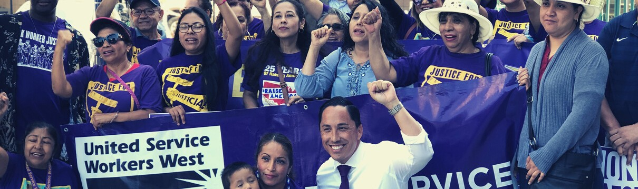

JUMP-STARTING OUR RECOVERY

PROTECT WORKERS AND CONSUMERS

The only way we can make progress on containing this pandemic and reopening our economy is by protecting the workers and families that drive it. San Diego residents and workers need to know that the City is looking out for them. Some neighborhoods, many in communities south of Interstate 8, have been especially impacted by COVID-19 fatalities and pandemic-related unemployment. These geographic disparities must inform the allocation of scarce public resources.

Key Strategies to Protect Workers and Families:

1. Study COVID-19 financial impacts by neighborhood and target resources appropriately.
2. Monitor and enforce public health order compliance and other workplace safety requirements
3. Implement and enforce worker protections such as minimum wage, sick leave.
4. Task City Attorney’s Office, law enforcement with monitoring compliance of public health orders and worker protections.
5. Partner with employers to promote telework options.
6. Ensure large employers offer a path back to employment for workers laid off due to the pandemic.

ENFORCING HEALTH ORDERS AND WORKER PROTECTIONS

Prior to sanctioning the reopening of any additional sectors, San Diego must have confidence that protections are in place to allow for safe business operations. The City must do all it can to monitor and enforce public health orders and workplace safety requirements to protect workers and customers alike from COVID-19. I will ensure that appropriate City Attorney and law enforcement resources are devoted to maintaining compliance and protecting the public from outbreaks that could jeopardize continued progress to contain the virus. City Council recently voted to pass an ordinance requiring specified large employers to provide a minimum of 80 hours of paid sick leave for COVID-19 related reasons. These protections and others provided for in state or local law aren’t much use unless they are appropriately promoted and enforced. San Diego must take more steps to inform workers and enforce protections. Another way the City can improve health outcomes is by implementing policies that incentivize teleworking options. Many workers enjoy the flexibility and security of being able to work from the safety of their homes. This also cuts down on traffic and related air pollution, helping the City meet its climate goals.

RETENTION AND REHIRING

While scarce local financial relief should be directed to small and micro businesses, efforts with larger employers should focus on retention and rehiring. City Council recently voted to pass an ordinance requiring large employers like hotels and event centers to recall employees by seniority and retain employees if the business changes ownership. This mirrors state legislation I supported in the Assembly. My administration will make implementation and enforcement of these protections a priority.

#Forallofus

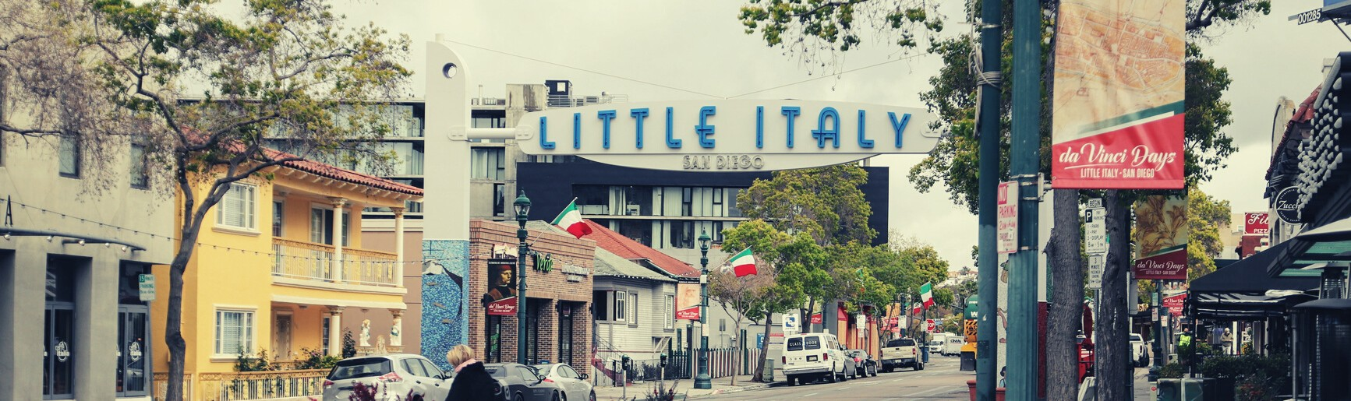

JUMP-STARTING OUR RECOVERY

CHAMPION OUR SMALL BUSINESSES

Many of San Diego’s businesses have faced incredible challenges and impossible decisions due to the COVID-19 pandemic. The impacts have been most severe for our smallest businesses and especially concentrated in service sectors like tourism, food, and beverage. A strong recovery for small business owners will necessitate minimizing red tape, empowering communities, avoiding ‘one size fits all’ approaches, and innovating city operations. Let’s become known as a city that embraces inclusion
and innovation and one that supports the growth of small businesses.

Key Strategies to Champion Small Businesses:

1. Create a permanent streamlined outdoor business permit program.
2. Update San Diego’s Complete Streets policy to make commercial corridors safer for cyclists, pedestrians, and people with disabilities.
3. Work with communities to allow for new car-free street openings. Reallocate parking district revenue for long-term outdoor dining and retail spaces, infrastructure, focusing on underinvested neighborhoods
4. Launch an “Invest in Local” campaign and accompanying city contracting policies. Review allocation of Development Services, Economic Development staffing resources.
5. Extend commercial tenant protections and provide commercial rental assistance. Expand small business retention funds.
6. Develop a pipeline to identity and refer at-risk businesses for technical and financial assistance.
7. Establish an “adopt a business” program for private sector support.

FLEXIBLE INFRASTRUCTURE FOR SAFE REOPENING

A world class city requires world class infrastructure. Even during the COVID-19 pandemic, we rely on a connected network of streets, parks, and utility pipelines in our day-to-day lives. Businesses rely on these shared resources at least as much. To support our economy, but also to maintain and improve our quality of life in San Diego, we must invest in our infrastructure. San Diego adopted a Temporary Outdoor Business Permit to allow for businesses to operate in the public right-of-way or in their parking

lots while safety restrictions are in place for indoor uses. We’ve seen businesses use their ingenuity to safely use both public and private spaces to redefine restaurants, cafes, and other businesses within new constraints. We can continue to support San Diego businesses by creating a permanent streamlined outdoor business permit program for use of the public right-of-way or private parking lots so that the best outcomes from the pandemic can continue even when the worst is over. The quick- and-easy outdoor business permit can also include easier permitting for placemaking and art to support the beautification of San Diego’s neighborhoods.

We can also create a permanent strategy to use the public right-of-way not only for outdoor dining on sidewalks and in parklets, but also for a wide variety of purposes. We will analyze potential policies to expedite use of the public right-of-way for bicycling and pedestrian improvements and avoid today’s delays in making multimodal street improvements. Numerous studies have shown that cyclists and pedestrians are good for businesses. I will partner with business associations and community partners to make sure our neighborhood commercial spaces are safe and appealing places to walk or bike. We will also streamline the City’s review of SANDAG bikeway projects, a dual agency review process currently stifled by extensive delays. We will reimagine San Diego’s Complete Streets policy to automatically add buffered bike lanes and prioritize safety and equity factors in street repaving plans. Every project and policy change will address the needs and rights of San Diegans with disabilities, to correct existing
issues and prevent future barriers to full accessibility.

Building on the popularity of transforming some streets into linear walkways with outdoor dining, we will support designating new and permanent or semi-permanent (weekend) car-free street openings. San Diego’s Business Improvement Districts have been at the forefront of promoting thriving businesses and improving infrastructure to benefit the whole community. My administration will work closely with business districts to ensure the success of these efforts.

It’s time to put parking district revenue to use for the benefit of businesses and commercial districts. We will explore ways to reallocate parking district revenue to support the creation of long-term spaces for outdoor dining and retail, along with the needed infrastructure to create pleasant outdoor use spaces, with a special focus on historically underinvested communities.
FINANCIAL RELIEF

Beyond policies and procedures, San Diego’s businesses also need financial relief to continue to employ and sustain the region. We will create a commercial rental assistance fund to aid businesses hard hit by COVID-19. Businesses will need assistance to pay rent and other expenses to get back on their feet. Recently passed state protections for residential tenants do not include commercial tenants, so the City must extend local eviction protections for small businesses. We will make San Diego an active
participant in the California Rebuilding Fund that is being supported by the iBank, Calvert, CRF-USA and the local Community Development Financial Institutions (CDFIs). It will be a $25 million fund to increase access to capital for hard hit small businesses, particularly businesses owned by minorities. We will ensure that the City participates fully in the Fund to make sure that San Diego businesses get their
share of support.

ENGAGING THE SMALL BUSINESS COMMUNITY

Funding alone will not save many businesses. We must prioritize robust education and technical assistance for businesses and community members to access new programs. It is imperative that the City create a strong alliance with organizations designed to support small businesses to provide
technical assistance, education, and financing within communities of concern. These programs would be administered by entities familiar with communities of concern. We’ll create a protocol to identify businesses that could use additional support and work with organizations to refer those businesses for technical and educational assistance. We will also launch a targeted campaign to market initiatives designed to support small businesses in conjunction with BIDs serving historically underserved neighborhoods of San Diego.

San Diego will launch an “Invest in Local” campaign in coordination with our Business Improvement Districts to highlight local businesses, entrepreneurs, manufacturers, and suppliers. An official policy pertaining to supporting local businesses in procurement and other areas of city policy will go a long way to supporting the local economy.

One way to support local businesses is to reallocate Development Services staff by zones in an equitable manner so that permit reviewers become familiar with the area in which they work. A customized, not “one size fits all” approach will be utilized. Beyond Development Services, this approach makes sense in other areas such as Special Events, Parks and Recreation, Transportation and Storm Water, Sustainability, and Economic Development. Economic Development staff resources should be allocated to provide more assistance to businesses and business districts with grants and relief
programs.

Another strategy includes creating an “Adopt a Small Business” program, where more established businesses can assist smaller or new businesses who might not have any access to QuickBooks, point of sale, or other helpful support for their business to succeed.

INVESTING IN

Even as we focus on the urgent need for immediate relief in the midst of the COVID-19 pandemic, San Diego cannot afford to drop the ball on long-term strategies that will enhance the economic opportunities and quality of life for our residents for many years. These investments are needed now more than ever to ensure a sustainable recovery and a bright future for San Diego.
OUR FUTURE

#Forallofus

Back to Work SD: A Blueprint for our Recov ry | Todd Gloria for Mayor 24

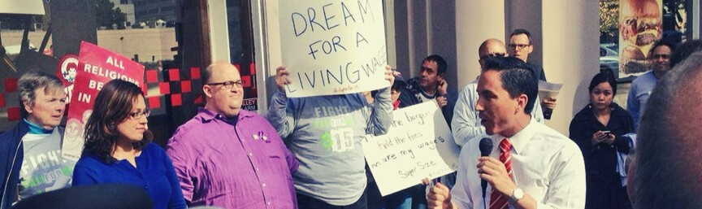

INVESTING IN OUR FUTURE

INVEST IN SAN DIEGO’S WORKFORCE

Beyond immediate financial relief, San Diego must continue to support and invest in our single greatest asset - our residents. San Diego is blessed with a diversified local economy that is more resilient to the disruption and dislocation of COVID-19 than other communities in California and around the country. Still, some industries in the City have been hit particularly hard, and some jobs will unfortunately not return. Although there are positive signs that some industries are recovering, the regional unemployment remained painfully high at 12.3 percent as of August 2020. Safeguarding the future of working San Diegans, as well as the attraction of doing business in San Diego, will require long-term focus on workforce development and ongoing investments in our precious human capital.

Key Strategies to Protect and Develop San Diego’s Workforce:

1. Analyze employment disruptions from COVID-19 to target workforce investments.
2. Partner with workforce development organizations and educational institutions to expand retraining and alternative credentialing programs.
3. Work with industry groups to remove barriers to hiring San Diegans with a history of long-term
unemployment.

TARGETING WORKFORCE INVESTMENTS

San Diego can leverage the expertise of local universities, business associations, and city offices to develop an integrated and real-time labor market tracking tool for San Diego. To properly target workforce development programming and continuing relief efforts, we need to understand employment impacts in more granular detail. Specifically, analysis should focus on answering:
What businesses and industries are being affected by COVID-19?
Which will return as San Diego gets back to work, and which will not recover? What is the profile of the workers who will be left without employment?

WORKFORCE DEVELOPMENT COORDINATION

San Diego benefits from strong workforce development institutions. We can expand cooperation with organizations like the Workforce Partnership and educational institutions to host online job fairs and certificate programs. The City will provide support for businesses that have not recovered from the pandemic and must pivot their business structure or employees for new opportunities. Engagement from the business community should ensure alignment between funding of programs and the needs
of businesses and workers.

San Diego will develop a robust marketplace of retraining and alternative credentialing programs that local employers commit to using when they hire new workers. As we come back to work from
COVID-19, the local labor economy is going to be transformed. For many San Diegans, that may mean switching industries, either because of an identified opportunity or out of necessity. We need
to ensure that San Diegans with relevant skills yet lacking a four-year degree – and disproportionately our Veterans, Black and Latinx neighbors – are not screened out of available skilled careers in growing markets.

The City should coordinate with the San Diego Workforce Partnership and area employers to develop tailored retraining programs for the moment we face, consolidating new and existing foundation and government funds into innovative online skill-building courses and placement programs. These should focus on industries most impacted long-term by COVID-19. San Diego should identify funding for a partial reimbursement program, potentially funded through future state or federal COVID-19 relief allocations, for employer-led retraining efforts targeted at retaining veterans and historically underrepresented groups. Finally, we can pursue a partnership with Opportunity@Work to bring its alternative credentialing STARs (Skilled Through Alternative Routes) Opportunity Marketplace to San Diego. Focused on San Diegans without four-year degrees, this effort will evaluate them through existing credential and training programs and create a vetted talent pool for local employers to access.

ADDRESSING LONG-TERM UNEMPLOYMENT

After the Great Recession, millions of Americans suffered from long-term unemployment, unable to get back into the workforce even post economic recovery. One contributor was corporate policies which screened out applicants who had been out of work for long periods. We can expect a similar phenomenon in the wake of COVID-19. We will lead in calling on employers to take a corporate pledge to remove barriers that may prevent qualified long-term unemployed job seekers from applying or being fully considered for jobs. Employers must ensure that:
Advertising does not discourage or discriminate against unemployed individuals.
Recruiting and hiring processes do not disadvantage individuals based on their unemployment status.
Job descriptions do not include archaic requirements that unduly screen out otherwise qualified applicants.
Credit scores are not used as a knock-out provision.

INVESTING IN OUR FUTURE

SUPPORT OUR TOURISM ECONOMY

Tourism is a key part of San Diego’s economy and an important source of city revenues through the transient occupancy tax. In 2018, San Diego received more than 35 million visitors, accounting for $11.5 Billion in economic activity and directly

supporting nearly 200,000 jobs. Unfortunately, tourism and hospitality have been heavily
impacted by COVID-19. Consumer confidence will be key as we prepare to welcome more visitors back to San Diego. As more tourist-serving
facilities are allowed to reopen, the City and San Diego Tourism Authority will need to invest in advertising to spread the word about the safety and unique attractions of San Diego as a travel destination.

Key Strategies to Support our Tourism Economy:
Tourism by the numbers

35 million visitors
$11.5 billion in economic activity
200,000 jobs

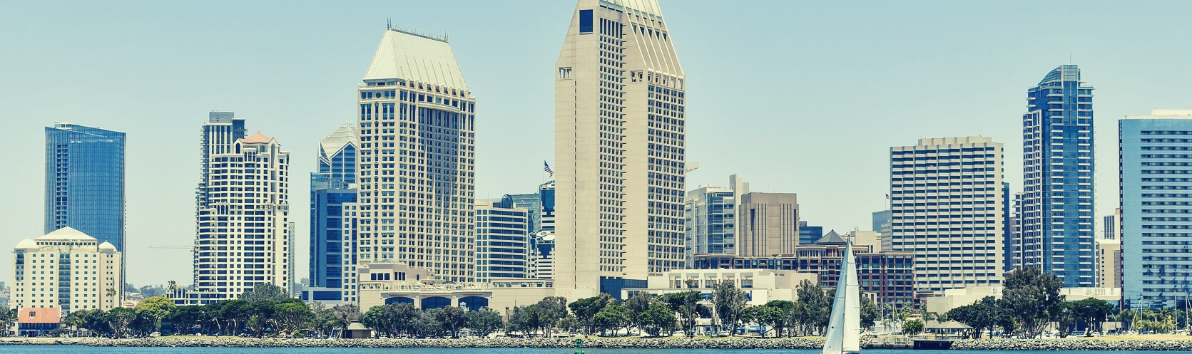

1. Facilitate a smooth transition at the Convention Center from shelter to convention business only once housing is available for current clients.
2. Prepare marketing and outreach campaigns to launch as more attractions can safely reopen or expand currently limited capacity.
3. Increase sidewalk cleaning and sanitation services.
4. Create targeted relief and retraining programs for hospitality and service workers.

RAMP UP SAFETY AND SANITATION PROGRAMS

Hotels and restaurants have implemented comprehensive cleaning protocols that reflect CDC guidelines. Expanding that concept to the City at large would make sure San Diego is known as a safe, clean destination for businesses and travelers. With the partnership of business improvement districts, private property owners, and other community groups, San Diego can mobilize again to accelerate street cleaning and other public safety measures in every neighborhood.

RELIEF AND RETRAINING FOR HOSPITALITY AND SERVICE
WORKERS

Hospitality and tourism sector employees have been especially impacted by the shut-down. The City can join with the San Diego Workforce Partnership, San Diego Regional EDC, San Diego and Imperial Counties Labor Council, and our local community colleges to make relief, rehiring,, and retraining of hospitality and restaurant workers a top priority.

#Forallofus

INVESTING IN OUR FUTURE

INFRASTRUCTURE INVESTMENTS TO
CDesRpiteEtheAmaTny EchalleLngAes cSausTed bIyNCOGVID-O19, SPan PDiegOo mRust TnotUhalNt proIgTressYon major redevelopment and infrastructure projects. These opportunities will help to spark economic recovery in the short-term and eventually provide world-class places for San Diegans to live, work, and play. Projects like SDSU West and redevelopment of the NAVWAR site are major investments in education and jobs. These investments will help get San Diegans back to work and generate new jobs and economic opportunities in the years to come.

SDSU WEST

Measure G will transform the former Qualcomm stadium site into SDSU West, a major new educational resource and employment center. This is a plan that future generations will thank us for. During the shut-down, high quality outdoor recreation within San Diego’s urban areas has been in higher demand than ever. A new river park will be an incredibly valuable new civic resource. This project will plant the heart of an economic boom in place of a parking lot. We are committed to an efficient but careful transition of the land in accordance with the will of the voters.

NAVWAR SITE REDEVELOPMENT

Redevelopment of the Naval Information Warfare Systems Command (NAVWAR) will keep the Navy and the many high-quality jobs in supporting industries in San Diego, while also providing an opportunity to transform San Diego’s under-invested transit system. A new mobility hub at the site will create improved transit connectivity to the San Diego International Airport, the largest airport in the nation without a major transit connection. It will also create transit and job-rich housing that contributes to our housing production and affordability goals as well as vehicle miles travelled and greenhouse gas emissions reductions. The City must help ensure that the Navy and SANDAG receive thorough input from the long-underserved Midway community and adjacent neighborhoods to ensure the end result maximizes neighborhood-serving amenities and upgrades to neglected infrastructure. I have worked closely with the Navy and SANDAG to pass facilitating legislation that also provides strong environmental and workforce protections.

SPORTS ARENA REDEVELOPMENT

The City’s Sports Arena property is deeply underutilized. It is also in need of major updates and renovations. Transforming and revitalizing this area will be a major boon for the Midway District and
the City at large. Redevelopment of city property must maximize public fiscal and quality of life benefits
- such as affordable housing, employment opportunities, community amenities, and new public spaces. Measure E will be on the ballot this November. It will revert height limits, only in the Midway District, to the underlying zoning established in the recently updated community plan. It is supported by the local community planning group and will allow redevelopment to include more parks and greenspace, other community amenities, and additional space for housing -- both market-rate and deed-restricted affordable homes. With several important changes occurring in the Midway District, the City will play an essential role in coordinating efforts and ensuring the voices of the community are instrumental as these projects move forward.

FIVE BIG MOVES

San Diego’s transit system has long been under-invested compared to the needs of our residents and our place as the second largest city in California. SANDAG’s new Five Big Moves strategy shows great promise to transform our regional mobility system. The plan puts forward a strong vision for what a world-class public transportation system in San Diego would look like. This vision is fundamentally shaped by five key strategies for mobility, collectively known as the 5 Big Moves - Complete Corridors, Transit Leap, Mobility Hubs, Flexible Fleets, and the Next OS. Significant new transportation infrastructure investment is crucial to ensure the efficient and affordable movement of workers and goods in the years ahead. That will only happen if the City leads. I am committed to fully utilizing the City’s leading role at SANDAG to ensure the final plan works for all San Diegans and that we create a transportation system that even our children and grandchildren will be proud of.

INVESTING IN OUR FUTURE

FOSTER ARTS AND CULTURE

Many San Diego nonprofits that promote arts and culture are struggling to stay afloat during the COVID-
19 crisis. Local artists are struggling as well. Achieving San Diego’s promise of being a great city means celebrating and investing in the full range of arts, culture, and heritage. Policies that prioritize inclusive arts and culture strengthen the identity and resiliency of our neighborhoods, give children opportunities to develop and create, and build cohesion among our many communities.

Key strategies to foster arts and culture:

1. Restore funding to arts, cultural tourism. Facilitate safe reopening of cultural centers through use of public outdoor space or municipal facilities like libraries.
2. Promote bi-national cultural collaboration.
3. Establish creative economy training pathways for young people.
4. Streamline permitting and reduce fees for placemaking projects.
5. Fund programming that promotes youth wellbeing through the arts. Invest in public art and community facilities with a focus on underserved neighborhoods.

REINVIGORATING THE CREATIVE ECONOMY AND TOURISM

The arts, culture and creative industries are key components of San Diego’s economy. They are vital to attracting and retaining corporations and their workers. We depend on our arts, culture and heritage sector to attract out-of-town visitors to return to our hotels and restaurants. This pillar of our economy has been hard hit by the COVID-19 shutdowns. We will work to revitalize the creative economy and its role in driving tourism with both short- and long-term initiatives, including:
Restore arts and culture budget to its peak including cultural tourism assets and initiatives. Safely reopen arts and culture with support from future federal COVID-19 relief funds.
Support outdoor performances in City parks along with other socially distanced activities already permitted and fast-track permits for street and sidewalk stages.
Establish a creative economy roundtable to strengthen nonprofit and for-profit collaboration.
Identify dedicated funding from a permanent source so we can be confident arts, culture, and heritage will be central to San Diego's 21st century identity.
Bi-national cultural collaboration to increase regional tourism and connectivity.

STRENGTHENING OUR CREATIVE WORKFORCE

San Diego’s creative economy workers are busy making theater, music, visual art, dance, film, television, writing, design, architecture, gaming, virtual reality and much more. Like all workers, they have been deeply impacted by the economic slowdown. We will particularly focus on youth and adults from historically marginalized backgrounds so the creative economy is equitable and open to every San Diegan.
Provide access to city funding from economic, neighborhood, and small business investment dollars for creatives and non-profit arts organizations.
Expand philanthropy to bring San Diego’s support for diverse arts, culture and heritage on par with other major cities across the U.S.
Convene education, workforce, creative youth and economic development collaboration to establish creative economy training pathways for young people, especially those from historically
marginalized backgrounds and lower income circumstances.

PLACEMAKING AND NEIGHBORHOOD VITALITY

Arts, culture and creativity are central to San Diego’s identity, from the cultural resources of Balboa Park to the diversity of our neighborhood festivals. Balboa Park and its cultural organizations are assets for us all and the visitors we need to see return. Our neighborhoods are where the many cultures in San Diego are shared, celebrated and passed-on from generation to generation everyday. By deepening the intersections between Balboa Park, neighborhoods and arts and culture, we will create greater community resiliency and empower residents to determine their future. Specific initiatives will include:
Strengthen governance in Balboa Park and identify funding to revisit its thirty-year-old plan, upgrade infrastructure for the Climate Action Plan and address years of deferred maintenance.
Enable creative placemaking that puts community members, artists, arts and culture organizations, and community service providers at the center of neighborhood vibrancy and economic success. Promote cultural districts throughout the City to bring support and attention to the residents, artists, nonprofit cultural organizations, and businesses collaborating to amplify neighborhood roots and strengthen them with new creative ventures.
Establish neighborhood creative economy hubs that merge creative programming and training, maker studios and shops, performance venues, exhibit spaces, public art, affordable housing for artists and residents, and community support services with accessible transit.
Foster public art that reflects San Diego’s great diversity in civic spaces and facilities across the City. Increase arts programming at community facilities such as neighborhood parks, recreation centers, libraries, and homeless service centers to increase access to arts, culture and creative opportunities through streamlined permitting and enhanced City/community partnerships.
Establish a city art gallery to highlight the work of San Diego’s creatives, showcase the City’s art collection and be a space for lecture, diplomatic, civic and public events.

LEADING AS

ONE COMMUNITY
As the second largest city in California and eighth
largest in the nation, San Diego has the duty and opportunity to lead. Our city is home to a beautiful and diverse range of communities and is deeply interconnected with many areas beyond our city, county, and even national borders. The Mayor of San Diego has an incredibly potent bully pulpit and a responsibility to bring our communities and partners together to achieve our shared goals.

#Forallofus

Back to Work SD: A Blueprint for our Recov ry | Todd Gloria for Mayor 33

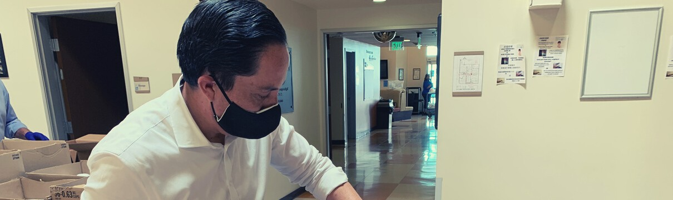

LEADING AS ONE COMMUNITY

PRIORITIZE HEALTH AND SAFETY

San Diego County’s recent removal from the state’s COVID-19 watch list is a sign that we are gaining ground but we cannot afford to lower our guard or relax public health measures too hastily. We must do
all we can to prioritize testing, treatment, and tracing to sustain progress on combating the virus. We must continue to emphasize the importance of following public health protocols like social distancing, hand washing, and facial coverings. These measures are saving lives but progress can easily be lost if we don’t remain vigilant in protecting ourselves and each other.

Key Strategies to Protect Health and Safety:

1. Advocate for release of more detailed public health data.
2. Coordinate health interventions and reopening procedures with other regional jurisdictions.
3. Focus health resources in underserved communities where outbreaks have been especially deadly.
4. Promote mental health resources through all City channels.

REGIONAL COORDINATED RESPONSE

The U.S. lacks a nationally coordinated response. Some states are forming alliances, like New York, New Jersey and Connecticut. They are coordinating public health policies to protect interconnected regions. In San Diego, we are impacted by outbreaks in Orange County, Imperial County, Tijuana and Mexicali. In the wake of the 2017 Hepatitis A outbreak, I brought forward a state audit and follow-on legislation to ensure better regional coordination in the event of future communicative disease outbreaks. These policies have brought improved cooperation and transparency to the region’s COVID-19 response. Only the leadership of the City of San Diego can bring together a truly coordinated regional strategy. County officials and local jurisdictions must be in close communication to sync public health policy and smart reopening strategies. Our regional approach must also emphasize transparency and a clear, unified message as we release as much information to the public as possible. Public confidence in the response to COVID-19 is vital to a successful recovery. Regional COVID-19 data clearly shows that historically underserved communities and especially Black and Hispanic residents have been disproportionately impacted by the pandemic. Our response must prioritize additional health resources for these communities.

PRIORITIZING MENTAL HEALTH

Now more than ever, mental health must receive the level of attention it deserves. In these times of incredible challenge and potential isolation, it is important for all of us to know and monitor for the signs of depression, anxiety, and suicide. All San Diegans need easy points of access to mental health services and equity in healthcare for mental illnesses. The City must continue to promote the use of existing resources such as 2-1-1 San Diego. I have championed funding and programming for mental health services for years. The City must continue to push the County of San Diego and other partners for additional support and better outcomes.

#Forallofus

LEADING AS ONE COMMUNITY

ADVANCE COMMUNITY-DRIVEN

TTheECitCy ofHSanNDieOgo hLas ObeenGa leYaderIiNn so-VcallEed SSmaTrt CMitiesEtecNhnoTlogyS. Unfortunately, many of these investments have been made without clear goals or community buy-in. To make San Diego a city for all of us, we must instead invest in bottom-up solutions that give all San Diegans access to their government as well as the information technology that has become essential to 21st century life.

Key Strategies to Advance Community-Driven Technology:

1. Invest in programs to deliver immediate internet and computing access to disconnected students and their families.
2. Study feasibility of various community internet network models to deliver free, universal internet access.
3. Establish Information Technology Advisory Board to assist in innovation and oversight for City technology ventures.
4. Pass and implement policies to protect rights and privacy of all San Diegans.
5. Expand online City services.
6. Develop new, more robust systems to gather citizen input.

BRIDGING THE DIGITAL DIVIDE

In the midst of the COVID-19 pandemic, the digital divide is more impactful than ever. Students and families need access to home computers and reliable, affordable internet service to participate in online classes, complete schoolwork, apply for relief programs, search for employment opportunities, access digital healthcare services, and so many other essential activities. While access to home computing and home internet are growing, the data clearly show that low income households and Black and Latinx residents are disproportionately being left behind . The City should continue to expand recent partnerships with private funders, schools, and nonprofits like Computers 2 Kids and the San Diego Futures Foundation to provide computers to San Diego students and families. Training and educational programs should complement these efforts to ensure students and families have the skills necessary to maximize the benefits of these programs.

Looking forward, San Diego should also explore options to create an integrated network that could provide free or heavily discounted internet service to all San Diegans. In 2020, internet access is absolutely an essential utility and should be treated as such. It would also empower workers and businesses to be more productive and flexible than ever. Hundreds of communities across the U.S. have implemented various forms of discounted or free internet service for residents. San Diego should follow their lead by studying the feasibility of solutions such as a franchise agreement similar to the energy franchise agreement the City is currently preparing for bids, a joint powers authority similar to the new San Diego Community Power, other P3 models, or full municipalization. Several studies have shown
that these community networks can offer significant customer benefits in terms of price, connection speeds, and customer service.

ACCESSIBLE AND TRANSPARENT GOVERNANCE

The City of San Diego has made several investments in technology solutions such as the Get it Done app. My administration will conduct a complete review of current information systems and customer- facing service platforms to look for efficiencies and opportunities for innovation. In the era of COVID-
19, it is more important than ever for civic information and services to be easily accessible to residents and businesses. The shift to digital development permitting through “Open DSD” is just one example of how the City can make it easier to do business. These tools must be designed with community and user input. Partners in that effort will include a new Information Technology Advisory Board to help inform the work of the City’s Department of Information Technology. The board will be made up of
community leaders, technology experts, civil rights and privacy experts, members of City customer groups, and representatives from organizations like Code for America and others that specialize in civic innovation.

NEW TOOLS FOR CIVIC ENGAGEMENT

San Diego must develop better ways for citizens to share feedback on City services and policy direction. Technology can be a great enabler for soliciting and making sense of much greater levels of citizen input, ideally before rather than after plans are developed and decisions are made. For these tools to be useful they must be representative and accessible to all San Diegans. My administration will work with the new Office of Race and Equity and other stakeholders to develop state of the art systems for citizen input and oversight.

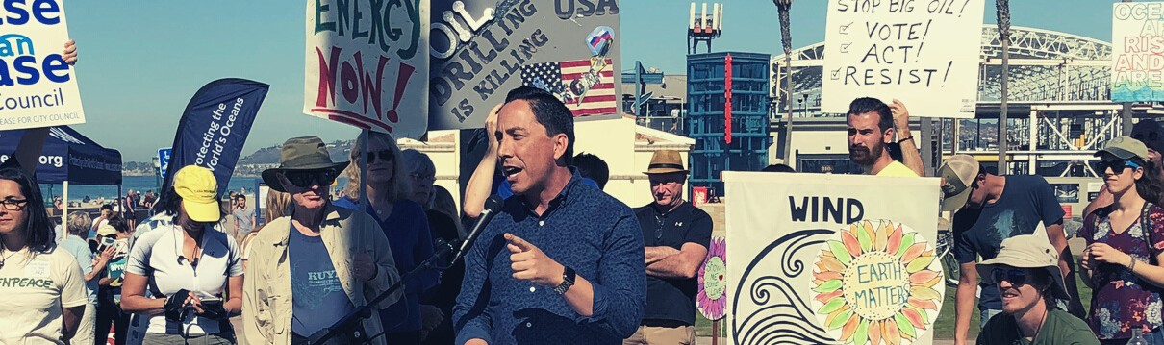

LEADING AS ONE COMMUNITY

ENSURE A JUST AND SUSTAINABLE

RECOVERY

As we chart a path to get San Diego’s economy back on track, we must also take the opportunity to address long-standing issues and injustices. The COVID-19 pandemic has exacerbated existing inequities, with negative health and financial impacts compounding on underserved communities -- primarily communities of color located in the Southern and Eastern parts of the City. Our response to the pandemic gives us an opportunity to center the needs of these communities as well as reexamine how existing practices impact our collective quality of life. Our actions should also advance the goals in our ground- breaking Climate Action Plan which I authored as Interim Mayor in 2015. The “new normal” after the COVID-19 pandemic recovery should be more just, sustainable, and resilient than what we started with.

Key Strategies to Ensure a Just and Sustainable Recovery:

1. Develop plans for equitable investments in parks, community facilities, and other city assets and processes.
2. Empower Office of Race and Equity to develop full range of equity and environmental justice initiatives.
3. Provide regional leadership for a San Diego Green New Deal.
4. Ensure planning and policy decisions are consistent with environmental and equity goals.
5. Partner with San Diego Clean Power to prioritize benefits and career opportunities for front-line communities.
6. Create opportunities to fund and pilot new sustainable technologies.
7. Convene stakeholders to set cleantech workforce objectives and attract external funding.

ALLOCATING CITY RESOURCES EQUITABLY

Building on a strategy that focuses on improving business districts in underinvested communities, we
will devise an equitable investment strategy for sidewalks and parks. That equitable investment strategy will include allocating funds to parks based on population density, poverty rates in the surrounding neighborhood, and historic underinvestment in specific parks. Working with City Council offices and
the new Office of Race and Equity , we will develop similar strategies for other City assets and processes.

SAN DIEGO GREEN NEW DEAL

A broad coalition of supporters has launched a campaign to advocate for a San Diego Green New Deal . This is a helpful framework to discuss regional efforts to invest in sustainable technologies and industries, correct a long history of disproportionate environmental and health impacts in communities of color, and create new opportunities for high-quality jobs in emerging green technology sectors. The City of San Diego must work with expert stakeholders and partner agencies to ensure that our policies and plans showcase leadership in climate action, green jobs, and social and economic justice. Relief programs and investments should be compatible with the principles listed by the San Diego Green New Deal Alliance.

As we’ve seen in recent weeks, wildfires, poor air quality, and other dangers exacerbated by climate change will continue to threaten our quality of life and economic success. Recovery efforts should therefore be designed to improve our resilience to climate impacts, so that future generations of San Diegans can safely enjoy a high quality of life in our beautiful home. San Diego must be resilient not only to the impacts of climate change but also to public health crises like the ones we’re facing now. San Diego is already leading on energy resiliency through energy storage projects and microgrid
innovations, but local customers are not seeing the full benefits of these new technologies.

The City should work with San Diego Clean Power and the next energy franchisee to prioritize the workforce training and infrastructure projects necessary to build a sustainable and resilient local energy grid. Additional efforts should focus on planning for sea level rise, safeguarding a sustainable water supply, and building up our urban tree canopy and greenspaces. All of these actions will protect our health, improve our quality of life, and establish greater resiliency to ongoing threats. With so many crucial decisions on the horizon -- including updates to the City’s Climate Action Plan, changes to land use planning regulations, major infrastructure investments, a renegotiated energy franchise agreement, a new regional transportation plan, etc. -- there couldn’t be a better time to commit to a San Diego Green New Deal.

OPPORTUNITIES IN THE CLEAN ENERGY ECONOMY

San Diego is blessed with diverse technology and cleantech industries as well as leading organizations
in green workforce development. San Diego already is home to more than 3,000 companies in the clean tech space, supporting nearly 40,000 jobs . This will continue to be a dynamic and growing field of work in San Diego. Organizations like Cleantech San Diego, Grid Alternatives, the Center for Sustainable Energy, and labor unions in relevant industries are already providing leadership on developing our cleantech workforce. The City must be a strong partner in ongoing efforts and lend support to priority industries through City planning and environmental action policies.

To stay on the forefront of the burgeoning clean energy economy, San Diego must continue to foster climate and energy innovation. We will convene startups and related support organizations, local universities, and environmental community groups to attract funding and empower clean tech entrepreneurs to help solve our environmental challenges. The City can support efforts to pilot these technologies and assist them in getting to market.

San Diego must take a lead role with San Diego Clean Power to prioritize benefits for front-line communities that have been subject to disproportionate climate and health risks for decades. These communities must also be at the front of the line for green workforce development initiatives and career opportunities.

#Forallofus

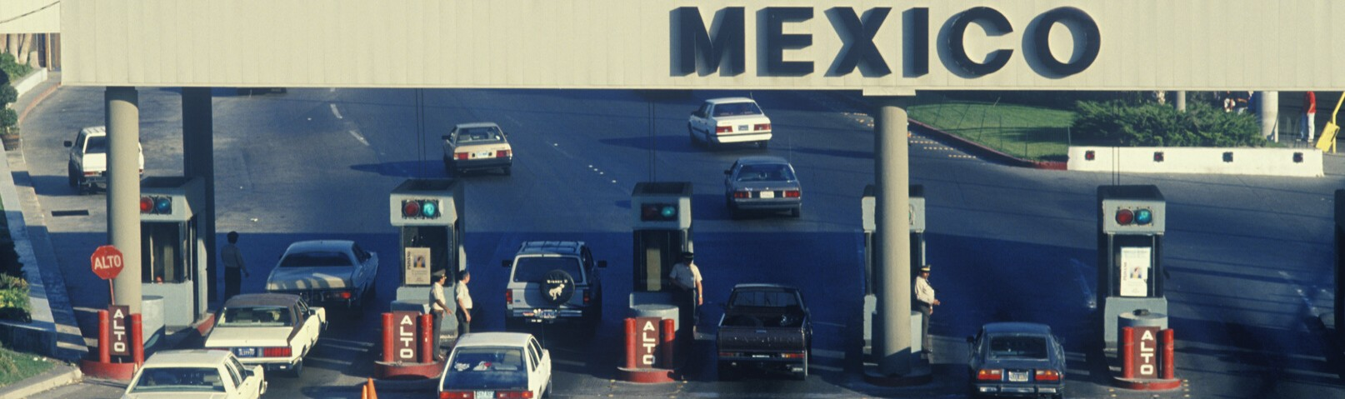

LEADING AS ONE COMMUNITY

STRENGTHEN CROSS-BORDER

COOPERATION

We share much more than a border with Mexico - our economy and well-being are intertwined. Our recovery is also dependent on continued binational coordination with Mexico. Economic impacts on one side of the border are typically mirrored on the other side. We share a workforce, a consumer market, and industry supply chains. The pandemic has highlighted our interdependency, impacting a variety of industries and resulting in tremendous job losses on both sides of the border. There is much we can do to further combat the spread of the virus while protecting our binational economy. Neither side of the border can succeed if one fails. Fortunately, our history of collaboration has developed strong relationships and lines of communication to address this challenge.

Key Strategies to Strengthen Cross-Border Cooperation:

1. Coordinate health response and reopening process with Tijuana and Baja California.
2. Join other regional leaders to advocate for cross border sewage solutions.
3. Marshal funding for investments that alleviate congestion and mitigate health impacts at border crossings.

PANDEMIC RESPONSE COORDINATION

We must advocate for federal coordination to lift travel restrictions at the land ports of entry. San Diego can coordinate with local and state government officials across the border to synchronize protocols such as the definition of essential businesses, binational contact tracing, and reopening timelines. Implementing a binational communication strategy would help to increase transparency and trust at the border.

ALLEVIATE CONGESTION AT BORDER CROSSINGS

The pandemic further highlights the need to advance sustainable and efficient border infrastructure to allow the safe flow of people and goods. Congestion at crossings have also had major negative impacts on border communities. Long wait times hurt our communities not only economically, with an estimated
$7.2 billion annually in lost economic output, but also increases air pollution, endangering public health. Border communities suffer from high rates of asthma and other health conditions which lead to higher risks for complications from COVID-19.

San Diego leadership must continue to push for federal government investments to alleviate congestion, facilitate trade, and reduce air pollution at the border. These efforts should include:

Restoring staffing levels and lanes at our ports of entry such that CBP operations reflect fluctuations in traffic volume to facilitate efficient travel across the border.
Advancing the construction of the Otay Mesa East Land Port of Entry. The Otay Mesa East Land Port of Entry will increase production sharing with more efficient supply chain linkages between manufacturers and the market.
Prioritizing the La Media Road widening project. This project will increase economic competitiveness by promoting sustained export activity, address environmental sustainability and
quality of life by reducing truck idling, and eliminating congestion caused by trucks on local streets.

#Forallofus

CONCLUSION

San Diego and all San Diegans will face unprecedented challenges in the coming years. We are in the midst of
a pandemic that has paralyzed our economy, taken our children out of school and taken the lives of many people who we know and love. Keeping San Diegans safe will be my top priority, as well as getting kids back in school and getting San Diegans back to work. This is not a small task and it will take months and years of work, dedication and collaboration. We will continue to lean on the members of this task force for their innovative ideas, leadership and dedication to San Diego. Together we will help create a safe, prosperous and equitable city in the years to come.

#Forallofus

Back to Work SD: A Blueprint for our Recov ry | Todd Gloria for Mayor 43

